QUANTIZING YOLOV5 WITH VITIS-AI

ANALYSING YOLOV5:

TRAINING YOLOV5:
Vitis-AI does not support the pytorch activation function nn.SiLU,
Q: What is nn.SiLU?
A: nn.SiLU is the Sigmoid Linear Unit function also known as the swish function,
silu(x)=x∗σ(x),where σ(x) is the logistic sigmoid.
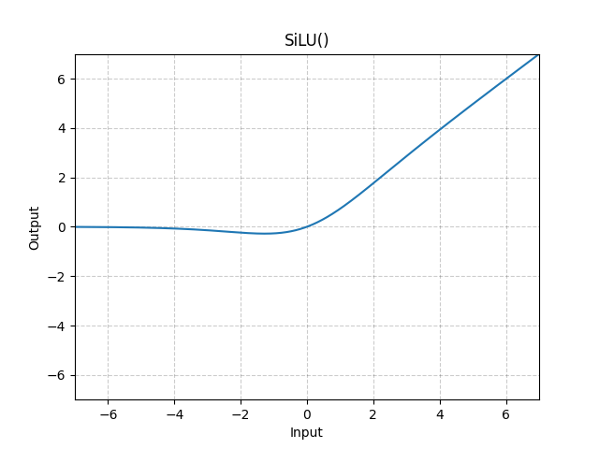

We will replace nn.SiLU with nn.LeakyReLU,
Q: What is nn.LeakyRelu?
A: An activation function where the negative section allows a small gradient instead of being completely zero, helping to reduce the risk of overfitting in neural networks, if the dataset is not too small leaky relu amy result in a more accurate model
LeakyReLU(x) = max(0,x)+negative_slope∗min(0,x)
or
LeakyReLU(x) = {x, if x≥0negative_slope×x, otherwise
{x,negative_slope×x,​ if x≥0 otherwise ​

where,
negative_slope – Controls the angle of the negative slope (which is used for negative input values). Default: 1e-2
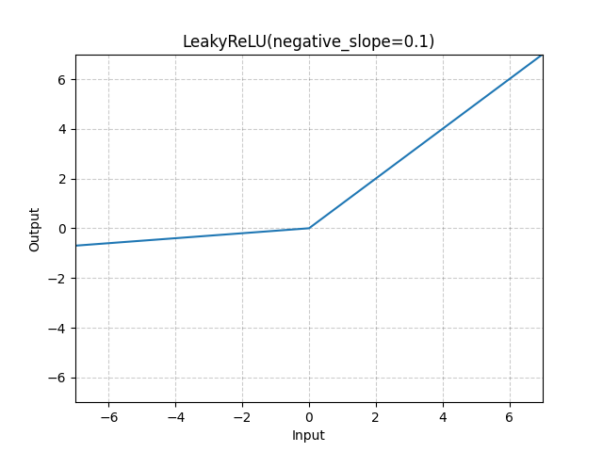

change all occurrences of nn.SiLU with nn.LeakyReLU(26/256, inplace=True)
The value 26/256 = 0.1015625 which is the negative slope for leaky ReLU only value supported by Vitis-AI. Now train the yolov5 model using train.py

QUANTIZATION:
The process of inference is computation intensive and requires a high memory bandwidth to satisfy the low-latency and high-throughput requirement of Edge applications. Quantization and channel pruning techniques are employed to address these issues while achieving high performance and high energy efficiency with little degradation in accuracy. Quantization makes it possible to use integer computing units and to represent weights and activations by lower bits Edge devices have limited computing resources and require low power consumption. To achieve this, smaller models and an accelerator are required to execute them at high speed. When the parameters are quantized from 32-bit to 8-bit, the model size is reduced. The bit-width of the accelerator also becomes smaller, allowing more of them to be equipped in the same area. As a result, processing can be performed faster. Hereafter, we introduce the typical methods used to quantize a model.

Generally, 32-bit floating-point weights and activation values are used when training neural networks. By converting the 32-bit floating-point weights and activations to 8-bit integer (INT8) format, the Vitis AI quantizer can reduce computing complexity.
The relationship between the floating-point number r before quantization and the quantized value Q are shown below using two parameters: the scale s and the zero point Z

s = fmax - fmin / Qmax - Qmin

Z = Qmin - (fmin / 8)

r = s(Q - Z)

Where fmax and fmin are the maximum and minimum values before quantization, respectively, and Qmax and Qmin are the maximum and minimum values after quantization, respectively.
The Vitis-AI conda environment(vitis-ai-pytorch) in the Vitis-AI docker image comes packaged with vai_q_pytorch which pytorch nndct which is a module to quantize the pytorch models
ANALYSING NNDCT(NEURAL NETWORK DEEP COMPRESSION TOOLKIT):

Since the permute and view are not supported in the Vitis-AI, remove the last layer in the detection head and reimplement that last layer in the post-processing section.
Take the forward function from models/yolo.py,
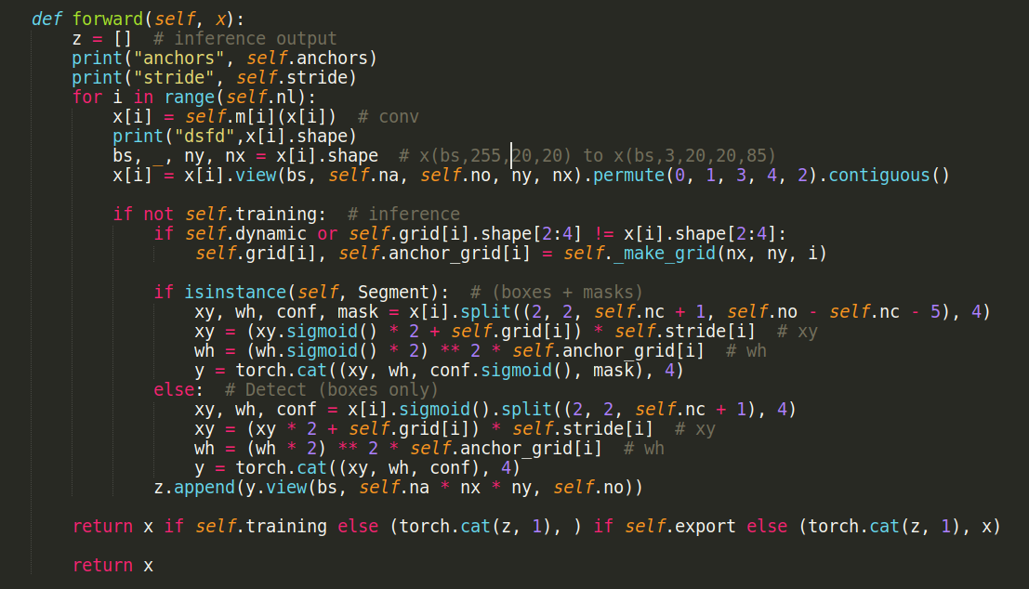

Comment out the following lines to prevent the forward function from forwarding the input through the model
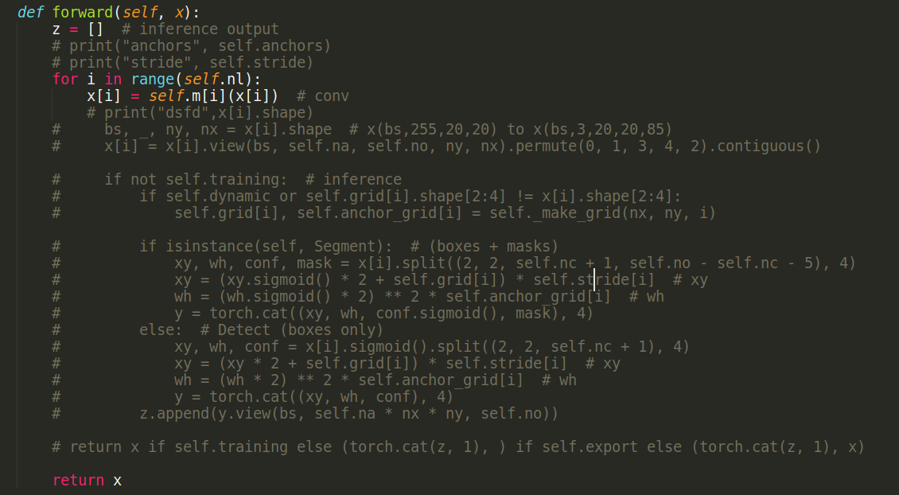
In the Detect.py file add the following function
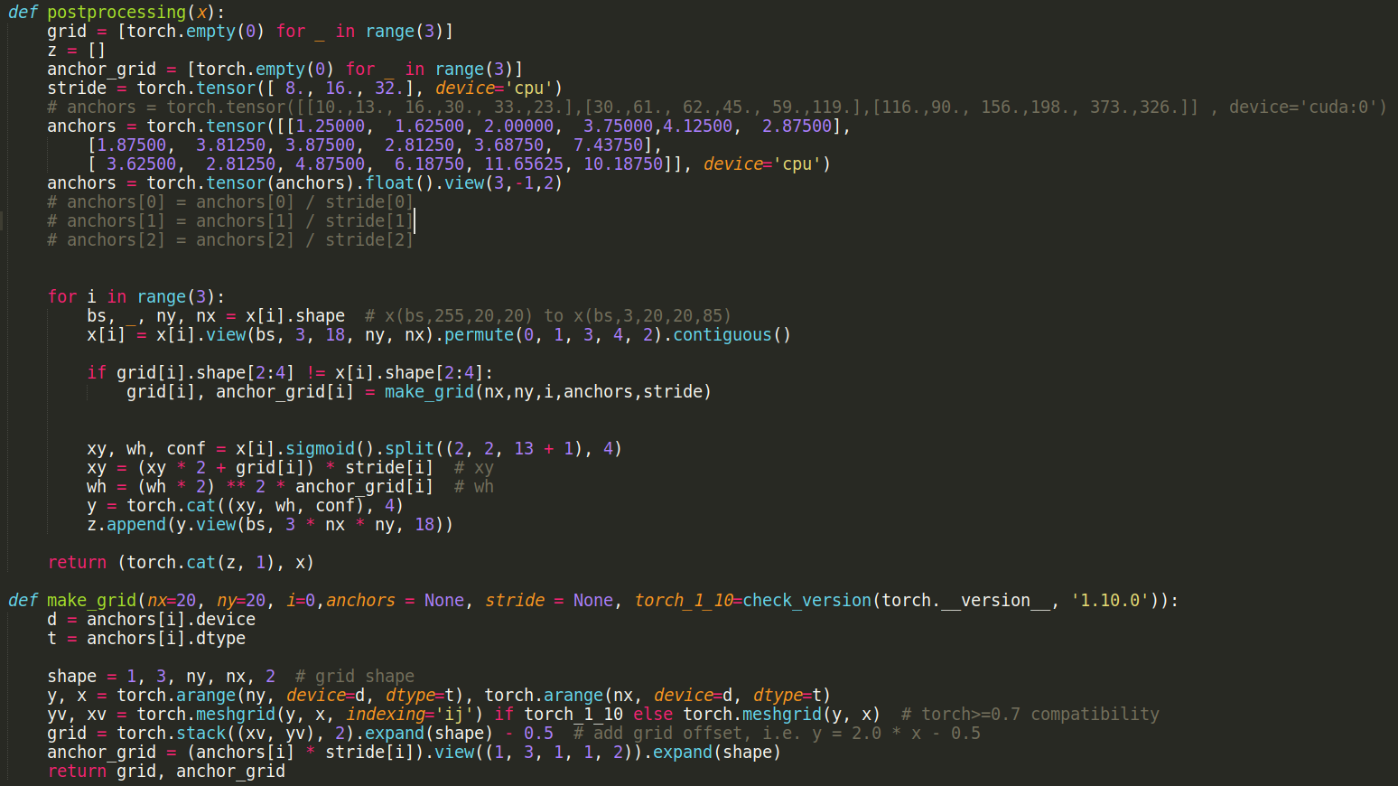

Create the quantization script, the quantization script uses DetectMultiBackend from
yolov5 models.common to load the float model
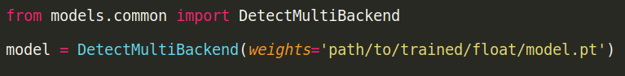
Using the torch_quantizer from nndct to quantize the float model
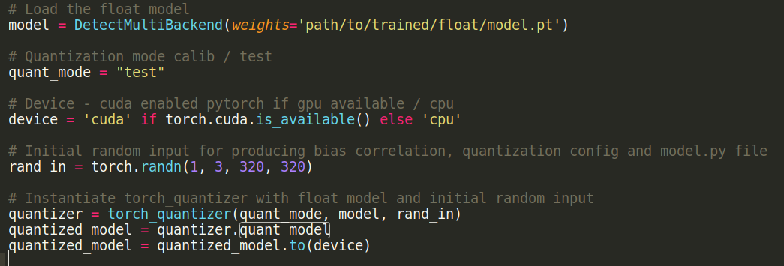
There are two quantization modes ‘calib’ and ‘test’,
‘calib’: perform model calibration, export the quantization configuration, collect details about the float model’s inputs.
‘test’: perform quantization testing, export the quantized model in different formats.
.onnx:
.pt:
.xmodel:

Viewing the exported models in netron
Float model

References:
- https://www.hackster.io/LogicTronix/yolov5-quantization-compilation-with-vitis-ai-3-0-for-kria-7b005d
- https://fpga.eetrend.com/blog/2022/100565582.html
- https://lgyserver.top/index.php/2023/05/08/xilinx-vitis-ai%E9%87%8F%E5%8C%96%E9%83%A8%E7%BD%B2yolov5%E8%87%B3dpu-pynq/

